Bavarian State Ministry of the Interior
2004 Constitutional Protection Report
Development of political extremism in 2004
Scientology Organization
Free Unofficial Translation (FUT) from Lermanet.com
...
Munich, April 2005
Dr. Guenther Beckstein, State Minister
Georg Schmid, State Secretary
...
Section 2.
Development of political extremism in 2004
1. | <SMALL>Right extremism</SMALL> | <SMALL>17</SMALL>
2. | <SMALL>Left extremism </SMALL> | <SMALL>19</SMALL>
3. | <SMALL>Foreign extremism</SMALL> | <SMALL>20</SMALL>
4. | Scientology Organization | 22
5. | Graphic presentation | 24
 | <SMALL>Section 3. Right extremism (includes Revisionism ... Lermanet)  Section 4. Left extremism  Section 5. Extremist and endeavors threatening security from foreigners </SMALL> | <SMALL>26  109  159</SMALL>
Section 6.
Scientology Organization (SO)
1. | On SO history | 243
2. | Ideology & Operations | 244
2.1 | SO publications | 245
2.2 | Setting up a Scientology society | 246
2.2.1 | Government control by Scientology | 246
2.2.2 | Introduction of a scientology legal system | 247
2.2.3 | Fighting criticism of teachings and practice -  aggressive expansion techniques | 247
2.3 | SO Activities
2.3.1 | Attacks on representatives of the State | 248
2.3.2 | Techniques of steering and controlling behavior | 248
2.3.3 | Investigating and combating critics | 248
2.3.4 | Scientology's periodical "free MIND magazin" | 249
2.3.5 | SO Activities abroad | 250
2.4 | Evaluation of writings and activities | 251
3. | Organizational and command structure of the SO
3.1 | Worldwide command structure of the SO | 252
3.2 | Organization of the SO in Germany
3.2.1 | "Church" sector | 254
3.2.2 | WISE sector | 255
3.2.3 | ABLE sector | 256
3.2.4 | Particularly active SO front groups | 256
3.2.4.1 | NARCONON | 256
3.2.4.2 | Kommission für Verstöße der Psychiatrie gegen Menschenrechte e.V.  (KVPM) | 257
3.2.5 | Office of Special Affairs (OSA) | 258
4. | SO members | 259
5. | Establishments and miscellaneous SO activities | 260
6. | Administrative Court proceedings | 261
7. | Internet Information and confidential telephone line | 263
 | <SMALL>...  Section 7. Counterespionage  Section 8. Organized Crime </SMALL> | <SMALL>264  270</SMALL>
. . .

4. Scientology Organization
The Scientology Organization (SO) continues to maintain the goal of making and governing a worldwide Scientology society according to its own rules, which disregard the fundamental principles of the basic German government system, the principles of democracy, the principle of a legal state and division of power. Its highest goal, world domination, stands in crass contradiction to its constant assertions of bringing complete peace to humanity because the implementation of its ruling principle would actually lead to a massive detriment to human rights. Until attainment of its goal the SO stands in fundamental conflict with all anti-Scientology people, social groups and states. In this setting the SO's 2004 propaganda measures included defamation of informational and countermeasures on Scientology.
In doing this the SO continues to engage in equating its observation by Constitutional Protection offices with the persecution of the Jews in the Third Reich. It continues to arrange information booths, exhibits and other propagandistic operations for the purpose of deceiving the public about its true counterconstitutional intentions and to recruit new members.
A focal point of the SO's expansion strategy is its endeavor to establish Hubbard's study technology in its alleged fight against educational woes and illiteracy. Its stated efforts to spread Hubbard's study technology with tutoring groups, for instance, primarily meant to spread Hubbard's teachings without being recognized as such and ultimately meant to recruit new members, has nevertheless had only slight success to date.
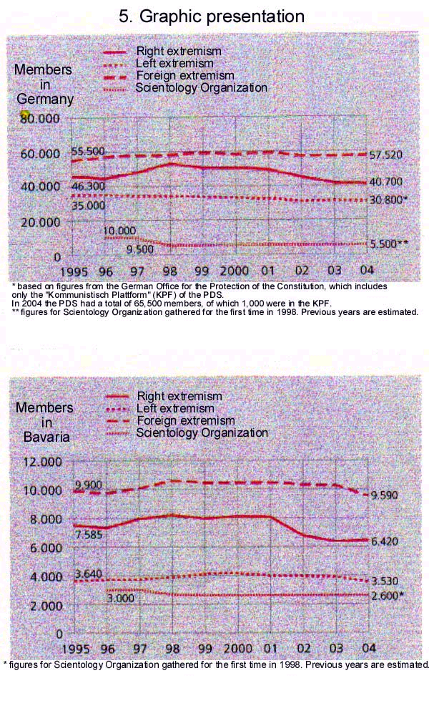
...

Section 6. Scientology Organization (SO)
 | International | Germany | Bavaria
members | 125-150,000 * | 5-6,000 | about 2,600
chairman | David Miscavige | Helmuth Bloebaum | Gerhard Boehm
founded | Los Angeles, 1952 | Munich, 1972 | Nurnburg, 1982
 | Church of Scientology  International | Scientology Kirche  Deutschland e.V. | Scientology Kirche  Bayern e.V.
headquarters | Los Angeles, USA | Munich, Germany | Munich/Nurnburg, Germany
 |  | (in Germany non-self-standing partial organizations)
Publications | Freiheit, Impact, Ursprung, Source, et al.
* estimates based on members' and former members' information

1. On SO history
In 1950 L. Ron Hubbard (1911-1986), American science fiction author, published the book "Dianetics: The Modern Science of Mental Health" in the USA. In it he wrote down his "technology" "with which can be treated all inorganic mental ills and all organic psychosomatic ills, with assurance of complete cure in unselected cases." It caught on to the extent that "Dianetics Centers" were founded in subsequent years and it eventually to the formation of the SO. In 1952 he founded the "Hubbard Association of Scientologists International (HASI), which had not yet made the claim of being a church or an applied religious philosophy. Hubbard nevertheless soon recognized the commercial and tax advantages of converting his organization into a church. For that reason he proclaimed the process of psychomanipulation he concocted himself, which he had developed with a totalitarian organization doctrine and practice in the form of a command system ("Admin tech"), to be a religion and founded the first "church" in 1954. The managers of the local establishments in the USA call themselves "ministers," wear church garb and attach the "Reverend" title to their names.
In 1957 the SO was granted tax exemption in the USA because it was rated a charitable organization.
After the Internal Revenue Service (IRS) uncovered facts indicating questionable personal enrichment for Hubbard and many of his functionaries, tax exemption was revoked for all Scientology establishments in 1967. It said in the basis for exemption that: Scientology practitioners are profiting from the 'non-profit' Church . . . The Church's activities are commercial . . . The Church is serving the private interests of L. Ron Hubbard.
The SO defended itself against this decision. In 1993 it reached a settlement with the IRS to again be recognized as charitable. According to a report from "The New York Times" the SO employed dirty methods of intimidation and coercion in doing this. IRS staff were spied upon, including their private lives, and overwhelmed with over 2,000 lawsuits, some of which were concocted. The instruction for this procedure is contained in a policy letter of Hubbard's from 15 August 1960 on the establishment of a "Department of Government Affairs," which describes methods by which government can be made tractable.
In addition Scientology has been in conflict with justice systems of democratic states. The accusations include fraud and usury against customers, threats and duress against critics, conspiracy against the government, tax evasion and formation of a criminal association. In this regard there have been many legal hearings and convictions for SO functionaries in the USA.
David Miscavige took over leadership of the SO in the middle 1980s, after Hubbard's death and power struggles rife with intrigue.

2. Ideology and Operations
According to a 5/6 June 1997 determination of the Federal and State Interior Ministers conference, there are actual indices for counterconstitutional endeavors from the SO.
The SO has fought the Constitutional Protection agencies surveillance orders for years with polemic, disparaging criticism and with reference to its alleged religious character.
The SO's ideology is based exclusively on the writings of L. Ron Hubbard, which are stated to possess invariable validity. In particular his programmatic statements in the "policy letters” are projected upon members and staff as compulsory orientation.
The SO's ideological superstructure rests on three columns: Dianetics, Scientology teachings and Scientology ethics. Dianetics' emphasis is primarily on the individual; it is dogmatized but contains actual social and political fundamentals and requirements. In the Scientology teachings, which are directed toward the "spiritual being" of man, what is called a "Thetan,” and contain the various steps of liberation, Hubbard prophesied that he would come back to Earth not as a religious, but a political, leader of the universe. Furthermore Scientology ethics describes disciplinary measures for members, staff and all society.

2.1 SO Publications
The analysis of a large number of the SO's primary material shows the scientology ideology makes general absolute claims. These are not just in relation to having possession of the only truth, but include people in all personal, as well as interpersonal and socio-political areas of life as soon as they are tied into the control system. Even the basic concepts of Scientology yield political dimensions that the scientology "technology" is supposed to change not only the individual, but the entire social and state relationship in the sense of a fundamental new order of society. In this connection a counterconstitutional system of values is not only propagated, but is to be established as a compulsory system factor for state and society.
In Germany the SO also proclaims loyalty to the person and the inalienable political program of its founder. Diverse SO program statements even indicate that it intends to implement its goals in a militant-aggressive manner. Correspondingly, a recruitment brochure of the International Association of Scientologists (IAS) expects its members "to support the destruction of groups that pursue the purpose of hindering the application of Scientology technology." No change in the ideological direction can be detected, instead writings in the above sense continue to be distributed. The internal directives and "policy letters" are also strictly adhered to.

2.2 Setting up a scientology society
Hubbard made references to the scope and political relevance of his teachings and technology as early as his fundamental "Dianetics" book. With the development of his totalitarian "Admin tech," which is published in eleven volumes, Hubbard created a socio-technical instrument for himself to make groups tractable. With these a world that functions exclusively according to scientology directives is supposed to be created. This new "true democracy" is supposed to replace current democracies, which Scientologists view as a product of an aberrated, meaning deviating from reason, mentally ill society. All social problems are supposed to be solved, first by "clearing" 10-15% of the political opinion leaders, then 80-98% of the population, and finally a society consisting only of so-called unaberrated people, "Clears," whereby the "incapable" or "unwilling," according to Hubbard, can be quarantined from society. "Admin tech" will supposedly be applied simultaneously worldwide in all the organizations of society and of governments.

2.2.1 Government control by Scientology
As of March 20, 1964 Hubbard presented the "International City" project in which he made claim to controlling governments worldwide. To this end Hubbard also wrote an instruction on March 13, 1961, in which a "Department of Government Affairs" et al. was supposed to exert constant pressure on government to hinder legislation of groups that oppose Scientology. Government offices and independent courts are seen by the SO as a danger that one confronts, and that sufficient threat against them should be constant sought or invented.

2.2.2 Introduction of a scientology legal system
The SO rejects existing legal systems. Those responsible for law would be limited to the "honest," namely those who have pledged themselves to Scientology.
As early as 1959 L. Ron Hubbard was expressing himself about the functions of the Scientology justice system in "Manual for Justice." According to that manual, a Scientology society would no longer have basic rights and human rights, as defined in German Basic Law. Independent courts are not provided for in the Scientology justice system. Besides that, an intelligence service not bound by law or justice (see also 3.2.5) would be investigating cases and taking measures.

2.2.3 Fighting criticism of teachings and practice - aggressive expansion techniques
In one of his fundamental works Hubbard promotes "total discipline." To maintain power, as evident from Hubbard's work, "Introduction to Scientology Ethics," one must proceed cold-bloodedly, unscrupulously, without restraint and, if needed, even maliciously, underhandedly and with force against one's enemies, otherwise power would be lost. The actions to counter "suppression" recommended in the "Manual for Justice" make it apparent that the SO intends to do away with the basic rights enacted in German Basic Law or to extraconstitutionally restrict their scope of protection to obtain the SO's total control of the individual.

2.3 SO Activities
2.3.1 Attacks on representatives of the State
All SO activities are directed toward the expansion of the organization. In this connection, measures to fight criticism are recognizable. Critics include any person or institution who does not agree with SO goals and resist its expansion. Detailed procedural instructions exist to "handle" these critics.
For this reason the SO has disparaged, vilified and libeled representatives of the Federal Republic of Germany in recent years in accordance with the HCO policy letter, which is still in effect. Moreover its disparagements are also directed against the Constitutional system itself in Germany, which is equated to that of National Socialist Germany.
Since June the SO's so-called human rights office ("menschenrechtsbuero") has published, in English, text of incitement, which had also appeared in 1999, about Germany's Constitutional Protection offices as an instrument of libel. It is asserted in the introductory comments that Germany's Constitutional Protection offices are characterized primarily by corruption, treason and crime, and that many Germans today believe that the Office for the Protection of the Constitution is an instrument for spying and incitement against minorities.

2.3.2 Techniques of steering and controlling behavior
With the effective techniques of steering and controlling behavior in the "technology," staff, as well as simple active members, are constantly manipulated and pressured like "machines," as the SO managers say, to make them adhere to the system and recruit customers. The pressure to perform the system puts on staff and members is so strong that orders from functionary proponents and the technocratic regulations of "Admin tech" are carried out, as a rule, without objection, in some cases even at the cost of infringing upon standards and function requirements.

2.3.3 Investigating and combating critics
People who practice just criticism are to be combated as "enemies" with attacks of chicanery and defamation. The goal of this is to have SO opponents designated as "suppressive persons," to silence them and to not let them put system expansion at a risk. Critics are defamed because of their opposition to the SO, are publicly compromised, charged and sued, occasionally threatened, harassed and mentally overwhelmed. One of Hubbard's 1966 management instructions, which is still in effect, addresses this:
"People who attack Scientology are criminals."
"That if one attacks Scientology he gets investigated for crimes."
"If one does not attack Scientology, despite not being with it, one is safe."
Because of this some media in the USA avoid openly taking a position against Scientology.
Also in Germany, critics of the organization are spied upon, including their intimate lives, by SO staff working covertly to publicly compromise them with defamatory assertions (see also 3.2.5 of this section).

2.3.4 Scientology's periodical "free MIND magazin"
"free MIND magazin," previously published in English and available only in SO internal organizational areas, has been published periodically in German. The first edition of the professionally laid out magazine contained articles like "The journey to I" and "Everything you always wanted to know about yourself and others." The external layout seems to be suited to address a broad stratum of people with esoteric ambitions without it being evident at first glance that this is a Scientology publication. "Scientology" is mentioned neither on the title page nor in the text section of the magazine. The Scientology origin of the magazine is not apparent until it is read. The magazine is devoted almost exclusively to Dianetics and to founder L. Ron Hubbard, whose life and work is radiantly described. A small book with the title "Dianetik - die Entwicklung einer Wissenschaft" was attached to the first edition.

2.3.5 SO Activities abroad
Although the SO continues to call the Federal Republic of Germany its most important area of expansion in Europe, its expansion efforts in many other European states are not insignificant and have not been registered by people and government without concern. Numerous legal proceedings against Scientology in France, Belgium, Spain and Italy demonstrate that infringement against the justice systems of those countries have been calculated for the purpose of expansion. Besides that, campaigns against alleged religious defamation, besides in Germany, have been conducted in the above named states, especially France. Those who participated in the erection of new organizational structures abroad included German Scientologists.
According to October 1998 press reports from France, hundreds of court documents against the SO disappeared from the Palace of Justice in Paris. In this connection the SO found itself experiencing accusations of infiltrating the justice system. In connection with the destruction of court documents prior to criminal proceedings against the Marseille SO in September 1999, the accusations of infiltrating the justice system were publicly repeated by the "Mission Interministerielle De Lutte Contre Les Sectes (MILS)," responsible for combating sects. Those proceedings ended in Marseille with a conviction for five SO personnel, who were sentenced to incarceration for fraud, with two of the accused exonerated.
In May 2002 the SO was convicted and had to pay a fine of 8,000 euro. The organization received a fine of 2,000 euro. The conviction came about as a result of a violation of the data protection law and unfair competition for the purpose of fraudulent machinations.
A criminal investigation against the SO in Belgium has been in process since October 1999 for fraud and other crimes. In the course of about 25 raids, thousands of personal dossiers on SO adherents, government officials, politicians and journalists were seized. The dossiers contained detailed medical information about the subjects of surveillance, reports on their private lives and their sexual conduct, statements about their families and "confessions" obtained with the use of Scientology "e-meters." In spring 2003 nine SO members were consequently charged with various crimes like fraud, infringement upon private sphere, illegal use of the pharmaceutical and medical professions, as well as membership in a criminal organization.
SO's Munich establishment, which it calls the Munich Org, has played a significant role in SO expansion in eastern Europe for years. Numerous eastern Europeans have been trained in courses at the Munich Org. According to one Internet press report the highest court of Bashkir Republic, in Russia, was said to have banned, with its February 9 decision, the Scientology "church" in its jurisdiction, because the organization carried out illicit educational and medical activities that have a negative influence on the psyche and mind of the trainees and threaten the public health. According to the court the SO had been active there since 1994, with over 2,000 people having taken SO courses.
In September 2003, the SO, with great media fanfare, opened a "human rights office" in Brussels, Belgium, which IAS financed. The intent was to demonstrate an important and influential presence as a political and administrative center and to perform lobby work. To this end, the SO stated, it has sent the informational brochure "Scientology - Answers and Solutions" on the most diverse themes to leading figures in Europe since the beginning of the year. The organization intends to reach 56,000 prominent personalities across Europe with its brochure in eight languages. A total of 672,000 brochures are supposed to be distributed. In Bavaria it is known that numerous communities, schools and security agencies have been recipients of this brochure.

2.4 Evaluation of writings and activities
According to a 2002 opinion by the "Institut für Therapieforschung" (IFT) the SO is in conflict with the Constitution's objective value system in many regards, because it not only has an internal system of standards whereby maintenance of organization interests, without exception, override those of the individual, but also because it has established for its adherents enemy images of people arbitrarily declared to be "suppressives." The internal organization, as well as the methods of surveillance and manipulation used against members and staff, according to the opinion, violate human dignity, general personality rights and freedom of opinion. Besides that the reigning social system, especially the principle of a social state, is massively criticized and denied. The SO allegedly uses its offices not only against individual persons, but also for the purpose of effecting personality changes for the establishment of Scientology social and state systems that are in opposition to the principles of our justice system.
The opinion corroborates the evaluation held to date by Bavarian security agencies. In a legal dispute between the SO and the Federal Office of the Constitution the Cologne Administrative Court confirmed that the SO pursues counterconstitutional goals, which are directed toward removing human rights, human dignity in particular.
The opinion appears under ISBN 3-936142-40-8 under the title "Gesundheitliche und rechtliche Risiken bei Scientology" from Pabst Science Publishers.

3 Organizational and command structure of the SO
3.1 Worldwide command structure of the SO
While SO establishments in Germany externally appear to be legally independent, they are still subject to the rigid authority of orders and discipline from the USA, and thus are dependent components.
The Religious Technology Center (RTC), under management of David Miscavige, is the SO's supreme command authority in the USA. The SO's International Management is situated under the RTC. Next to RTC, International Management is the SO's highest management plane and is responsible for developing tactical plans for every sector of SO strategy. This is also where the leadership of the various sectors is coordinated. Those sectors include the areas of "church," WISE, ABLE and OSA. International Management consists of several groups, each one of which is accorded very specific responsibilities. At the highest step of this leadership plane is the Watch Dog Committee (WDC). This is an inspection and monitoring organization that inspects the actual management groups and sees to it that they function.
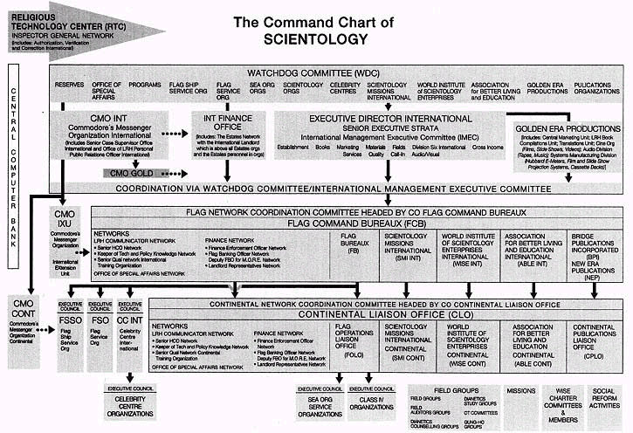

3.2 Organization of the SO in Germany
3.2.1 "Church" sector
At the present time the federal territory has ten "churches" (Orgs) and "Celebrity Centres" (CC), with an Org and CC each in Munich, Dusseldorf and Hamburg, and an Org each in Berlin, Stuttgart, Frankfurt am Main and in Hannover. In addition there are also eleven "missions" in Germany, six of which are in Baden-Wurttemberg, one apiece in Bremen and Hessia, as well as three in Bavaria, namely in Munich, Nurnburg and Augsburg. The Organization of the SO in Bavaria is presented on the next page of this report.
The named SO establishments are predominantly organized as registered associations. Functioning as the group association is the "Scientology Kirche Deutschland e.V." (SKD). These associations are only seemingly independent; they hardly have any independent functions in the worldwide system directed from the USA. Management of the SO establishments is not in fact carried out by the respective boards of directors, but - according to what is laid down in the license agreements between the organization's bosses in the USA and the local "churches," "missions," etc. all over the world about the application of Dianetics and Scientology trademarks - by the Executive Directors and miscellaneous functionaries according to detailed instructions and directives from the international management in the USA about the respective liaison positions. Among other things this shows that members of the Sea Org elite organization from the USA and the Continental Liaison Office in Copenhagen, Denmark are delegated to communicate SO instructions to SO establishments in Germany and to see to the proper "handling" of Scientology technology.
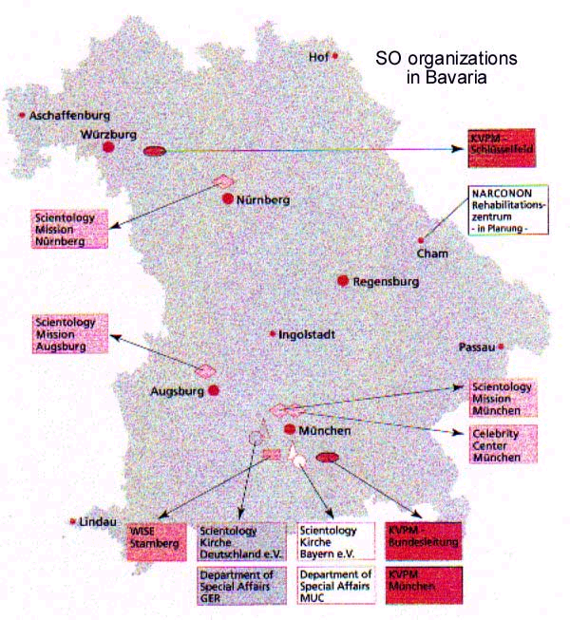

3.2.2 WISE Sector
The SO established the World Institute of Scientology Enterprises (WISE) in 1979. It consists of business people and firms from all areas of commerce. The purpose of WISE is to make money for the SO and to exert influence on society through the spread of technology based on that of L. Ron Hubbard. In that regard WISE also bears its share of political significance.
Focal points in Germany and Bavaria are real estate, as well as business, management and personnel consulting; besides that the area of information technology (IT) has become another object of Scientology interest in Bavaria. The IT area, because of the global network and its technology possibilities, presents a special risk for the security of German businesses, since access has been opening in the most sensitive areas of business.
For some time the focal point of SO expansion endeavors has lain in eastern Europe (Russia, Hungary). Continental WISE offices for Europe are located in Copenhagen, Milan, Budapest and Moscow. "Hubbard Colleges of Administration are actively used to establish Hubbard's administrative technology as supposedly successful western know-how in business and government.

3.2.3 ABLE sector
The Association for better Living and Education (ABLE) endeavors to permeate the social areas of society for the SO and have Scientology solutions recognized.
The main organizations in the ABLE category are:
- the "Zentrum für individuelles und effektives Lernen" (ZIEL),
- "Applied Scholastics" (education programs, including a long-distance English course)
- "NARCONON", an alleged drug rehabilitation program
- "CRIMINON", a program for alleged rehabilitation of convicts
With these organizations the SO endeavors to portray itself as a humanitarian, charitable and socially responsible organization. The focus on the selection of education and rehabilitation of convicts and drug addicts lets the conclusion be drawn that it is these groups of people who offer the possibility for easier exertion of influence to recruit them for the SO.

3.2.4 Particularly active SO front groups

3.2.4.1 NARCONON
In 2003 members of the SO in Munich founded a new association "NARCONON Bayern e.V." Since that time this association has endeavored to establish a NARCONON Rehabilitation center in Cham county. It got as far as having citizens stage a protest against the plan, which delayed it considerably.
According to the SO, "Europe's greatest" NARCONON center opened in Tyrol, Austria.
The SO recommends the following for the founding of a NARCONON establishment:
"Anyone interested in opening a NARCONON center based on the technology of L. Ron Hubbard as a pioneer should first contact a representative of NARCONON International or the nearest NARCONON center, which will help him. NARCONON International will then provide the advice, direction and materials needed for a start." (cited from "Was ist Scientology?", page 514)
Those who undergo a "NARCONON" withdrawal participate in "training routines," among other things, which is also part of the training program used by the "church" to prepare auditors. Another part of the course is a "Purification Rundown," which in the "church" needs to be completed before auditing begins.
A representative from NARCONON has been convicted in Germany for violating the law on medical practice. It was found at the time that neither the chairman of the "NARCONON-Schliersee" association nor the person conducting the treatment were competent or qualified.

3.2.4.2 Kommission für Verstöße der Psychiatrie gegen Menschenrechte e.V.
The KVPM is an organization tied to the SO that operates in the area of "social reforms." It was founded in 1972 with SO members. According to its own public statement, it goal is to investigate and uncover abuse and human rights violations in psychiatry. According to internal publications not meant for the public though, it actually pursues the goal of helping to create a new civilization, a new Scientology society. The KVPM resides in the Office of Special Affairs (OSA) of the SO.

3.2.5 Office of Special Affairs (OSA)
OSA is the successor to an organization established in the 1960s under the name of Guardian Office (GO), which perceives itself as having intelligence and espionage functions. Numerous GO primary documents, e.g., for intelligence training, were assumed in the new agency as OSA-Network Orders. In contrast to the GO's rigid and direct methods of procedure, which has led to an international loss of respect for the SO in the past, today OSA perceptibly operates more cautiously, but without having basically changed its goals.
The OSA component that has jurisdiction in Germany is the Department of Special Affairs (DSA), headquartered in Munich since its transfer from Hamburg on November 13, 1971. To external appearances DSA is designated as "Scientology-Kirche Deutschland, Beich Strasse 12, 80802, Munich", but the unofficial headquarters is Nordend Strasse 3 in Munich.
Subordinate to the central post of DSA-Deutschland are the local DSA offices in Berlin, Dusseldorf, Frankfurt am Main, Hamburg, Munich and Ulm, which are located near the local "Scientology churches" or "Celebrity Centres."
The SO itself represents its OSA unit in Germany, headquartered in Munich, as the office for public affairs or as the press and legal office. Parts of OSA are the German Human Rights Office and the Citizens Commission on Human Rights (CCHR). Because the CCHR gives direction to the Kommission für Verstöße der Psychiatrie gegen Menschenrechte e.V., the latter can be also be categorized as a public designation for the OSA sphere of the fight against psychiatry. The "Aktion Transparente Verwaltung München" (ATV), operated by a DSA section chief, can also be categorized as OSA. The ATV maintains a home page on the Internet, but no reference to Scientology can be recognized there.
The effort alleging human rights violations against Scientologists by hostile states and their government agencies is an essential component of the expansion endeavor, just as Hubbard waged the fight against psychiatrists, who he said were the source of all the evils in the world.
According to Hubbard's instruction (HCOPL) of March 13, 1961, OSA should maintain current files on actions OSA/DSA takes against "enemies" (those who critically oppose the SO). The HCOPL describes the goal of the department:
"The goal of the department is to bring the government and hostile philosophies or societies into a state of complete compliance with the goals of Scientology. This is done by high-level ability to control and in its absence by a low-level ability to overwhelm."
DSA-Deutschland implements this instruction to the letter, and collects information on critics, politicians, members of government and other opponents, evaluates it and applies it in its own operative measures. Using false names and other measures DSA-Deutschland obtained internal papers from German establishments. Its field staff carry out surveillance on designated opponents of the SO as "enemies" and use private detectives in doing so to avoid the work being traced back to the organization.
Internally DSA operates apart from other SO structures. Long-distance transfer of information to subordinate establishments is encrypted or arranged through special messenger.

4. SO members
The SO has between 5,000 and 6,000 people nationwide, whereby the organization itself presents the figures as much higher. The SO used to claim that "Scientology Kirche Deutschland e.V." (SKD) had over 30,000 members, however in a legal dispute between the SO and the federal Office for the Protection of the Constitution (also see number 6 of this section), the president of the SKD said the number was more like 12,000.
Membership in Bavaria has remained constant at about 2,600. People understood to be members are those who have declared their membership in a SO association or other SO entity, e.g. WISE or ABLE, or who have indicated membership by taking a course in an association.

5. Establishments and miscellaneous SO activities
The focus of SO activities meant for the public in Bavaria were the information stands set up primarily in Munich, and also occasionally in Augsburg and Nurnburg. It was apparent that the SO held basically more public events than in previous years. A reason for that might have been the passing of the 50th anniversary of the founding of the first "Scientology Church" (USA, 1954).
While the Scientology Kirche Deutschland e.V. or Scientology Kirche Bayern e.V. strove to bring attention to drug problems with their information, the theme of the front group Kommission für Verstöße der Psychiatrie gegen Menschenrechte e.V. was alleged abuses in psychiatry. These themes served only as excuses to decry an allegedly horrible state of affairs. Rosters were put out at many establishments for victims or citizens to register in this regard. The people whose names were on the lists would then have informational material sent to them, as the SO itself reported on the Internet, to eventually win them as new members. Despite the organizers' best efforts, there was little public resonance to these events.
Besides its public events the SO also conducts numerous mass mailings in which pamphlets and the "Freiheit" magazine are distributed in great number. In connection with the illicit distribution of recruitment material on the public thoroughfare, several street recruiters have been notified about violating Bavaria's right-of-way law. Two of those were convicted in Munich Municipal Court.
Besides that Scientologists, as in the past, have distributed the "Die Fakten über den Joint! Sag NEIN zu Drogen" brochure at police stations, accompanied by statements saying these should also be distributed at schools and government offices. In the propagation of Scientology's proposed solutions to the drug problem, victims are supposed to be motivated to sign up and pay for SO services (sale of books, courses, "Purification Rundown," etc.).
SO condemns the current educational and school system as incapable of providing students with "true skill and mental ability." In this connection a blurb from Hubbard's "Basic Study Manual" of 1992 says
"Gain the skills the school system never provided you with - and begin to really apply what you learn!"
In celebrating the 19th anniversary of the International Association of Scientologists (IAS) at the end of 2003, when the expansion goals for 2004 were given, David Miscavige, the head of the Religious Technology Center (RTC) said in his speech that the study technology must be everywhere, that it was the means whereby the "tech" could be introduced into every school and the problem could be solved on a global level. The organizations and all Scientologists worldwide were called upon to introduce scientology study technology into society.
A call to Scientologists to set up numerous tutoring groups around their "churches" and "missions" to spread Hubbard's study technology and recruit new members has met with little success so far .
In the sphere of tutoring, however, a member of the SO "I help" front group has set up business near Munich University and offers Hubbard's study technology as tutoring without saying, for the most part, that "Hubbard Tech" is being used.

6. Administrative Court proceedings
On November 11, the Cologne Administrative Court, after a full verbal hearing, completely dismissed the SO complaint about being under surveillance by the federal Office for the Protection of the Constitution (OPC). Appeal was permitted because of the fundamental significance of the case (Az. 20 K 1882/03). The court specified in the basis that it was of the opinion that surveillance of the "Scientology Kirche Deutschland e.V." (SKD) and "Scientology Kirche Berlin e.V." (SKB) using both overt and covert means was just, because significant factual indices indicated that the plaintiff was pursuing counterconstitutional goals. A number of sources, some of which were not publicly available, indicated that the plaintiff pursued endeavors directed at the removal or delegitimization of human dignity, the right to life, corporal integrity and equal treatment, as well as at the right of citizens to exercise their power to vote. The possibility that the attainment of these goals was, for the time being, hopeless, was of no importance to the issue of the justice of having the plaintiff under surveillance. The court said that surveillance of the plaintiff was also required, appropriate and completely proportionate. This was said to also be relevant in the event the plaintiff claimed to be a religious association. The decision also made it clear that Scientology was not only pursuing counterconstitutional goals in theory, but in practice, too. The court's references that fighters had to be recruited for Scientology and that, finally, Scientology pursued the concept of undermining the constitutional system, pointed in the direction of a method of operation that was designated as militant-aggressive. The Cologne administrative court decision also provided indications that supported deliberations about prohibiting Scientology associations in Germany.
In its response of August 15, 2003 to the complaint, the OPC attorney gave a detailed presentation of actual, existing indications for the counterconstitutional and, in part, even militant-aggressive endeavors of the SO against Germany's democratic system of government, as well as of crimes like fraud and coercion. Here are a few quotes from that response:
"Scientology sees itself in a life or death struggle with the rest of the world, and from this it is comprehensible why Scientology permits this struggle to be waged without hindsight, without borders and by any means."
"It is obvious that a group with this perception, should it ever attain a definite or even dominant influence in a state, would erect a reign of fear and terror directed against the suppression, if not the complete annihilation, of its opponents."
"Scientology constantly endeavors, anywhere and anytime, to learn what to use in any way against its critics. This is then used to intimidate critics with the threat of exposure. This is a question of systematic criminal coercion in the sense of § 240 StGB, because the information used to openly discredit the critic has nothing to do with the criticism of Scientology."
"Scientology defames its opponents on the whole as "suppressive persons" who must be fought with any force. In a Scientology dominated society opponents of Scientology would have no rights and would have to count on being persecuted with measures counter to those of a legal state. Scientology takes into consideration neither Germany's democratic system of government, including the right to education and the right to practice opposition, nor would citizen or human rights be guaranteed in a Scientology society."

7. Internet Information and confidential telephone line
The Bavarian government provides a confidential telephone line and information about Scientology over the Internet at:
http://www.innenministerium.bayern.de/scientology
Last updated: May 30, 2005

